1. QA2 Provider Account – Images stored under patient details

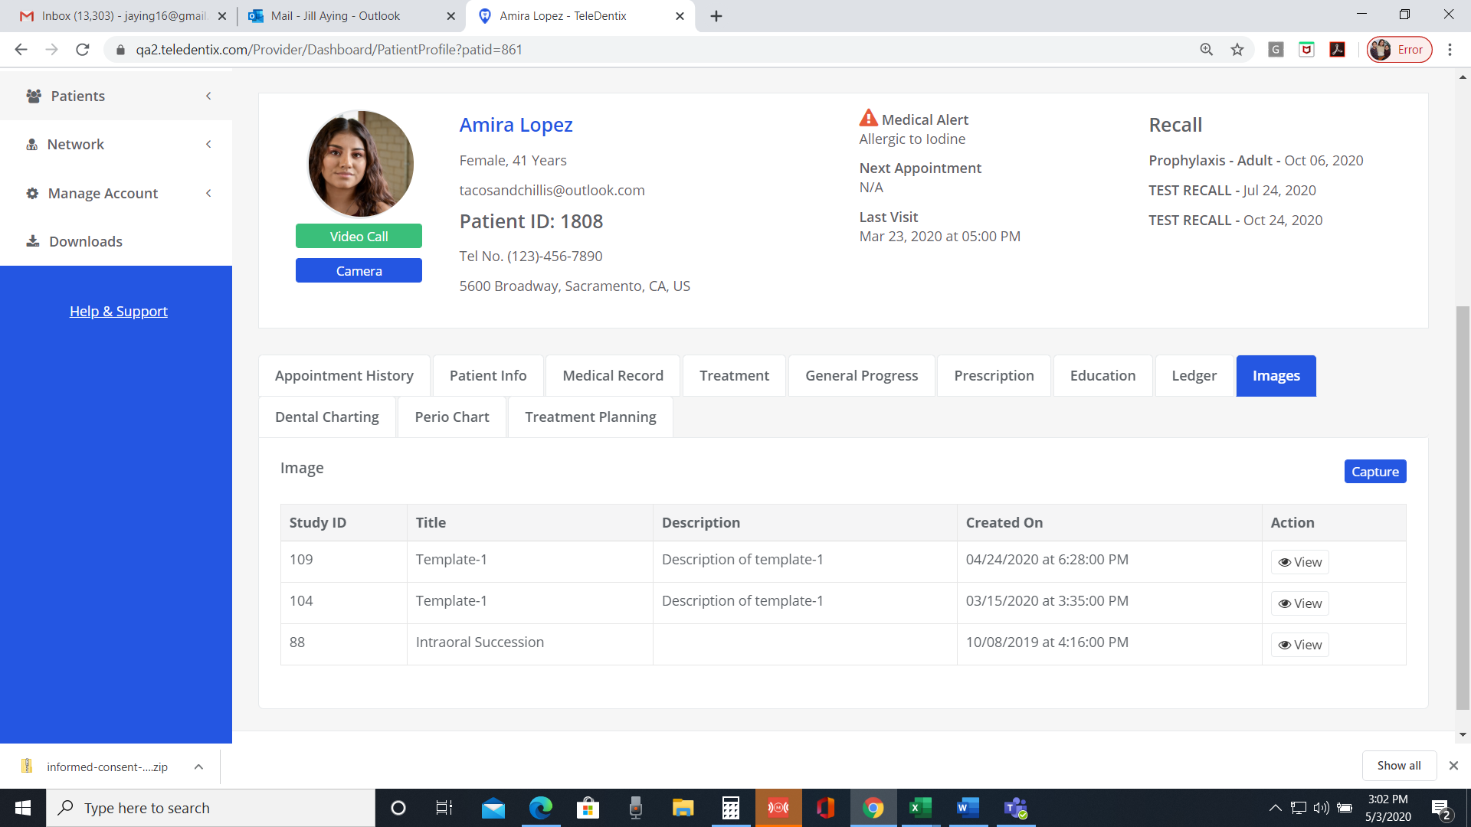

QA2 Teledentix Admin – No Image found

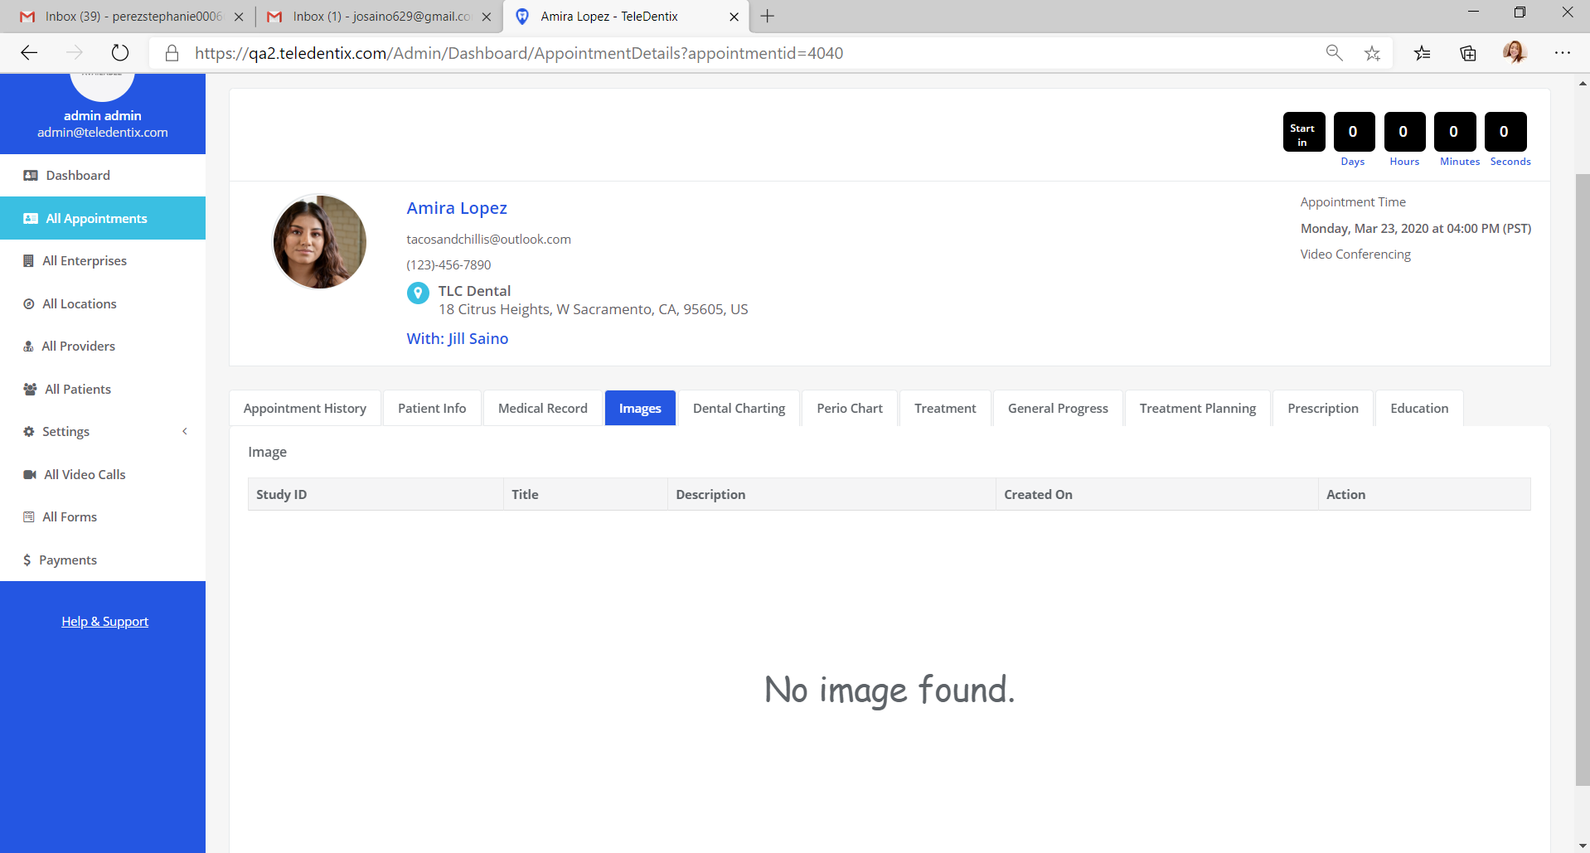

1. QA2 Provider Account – Dental Charting

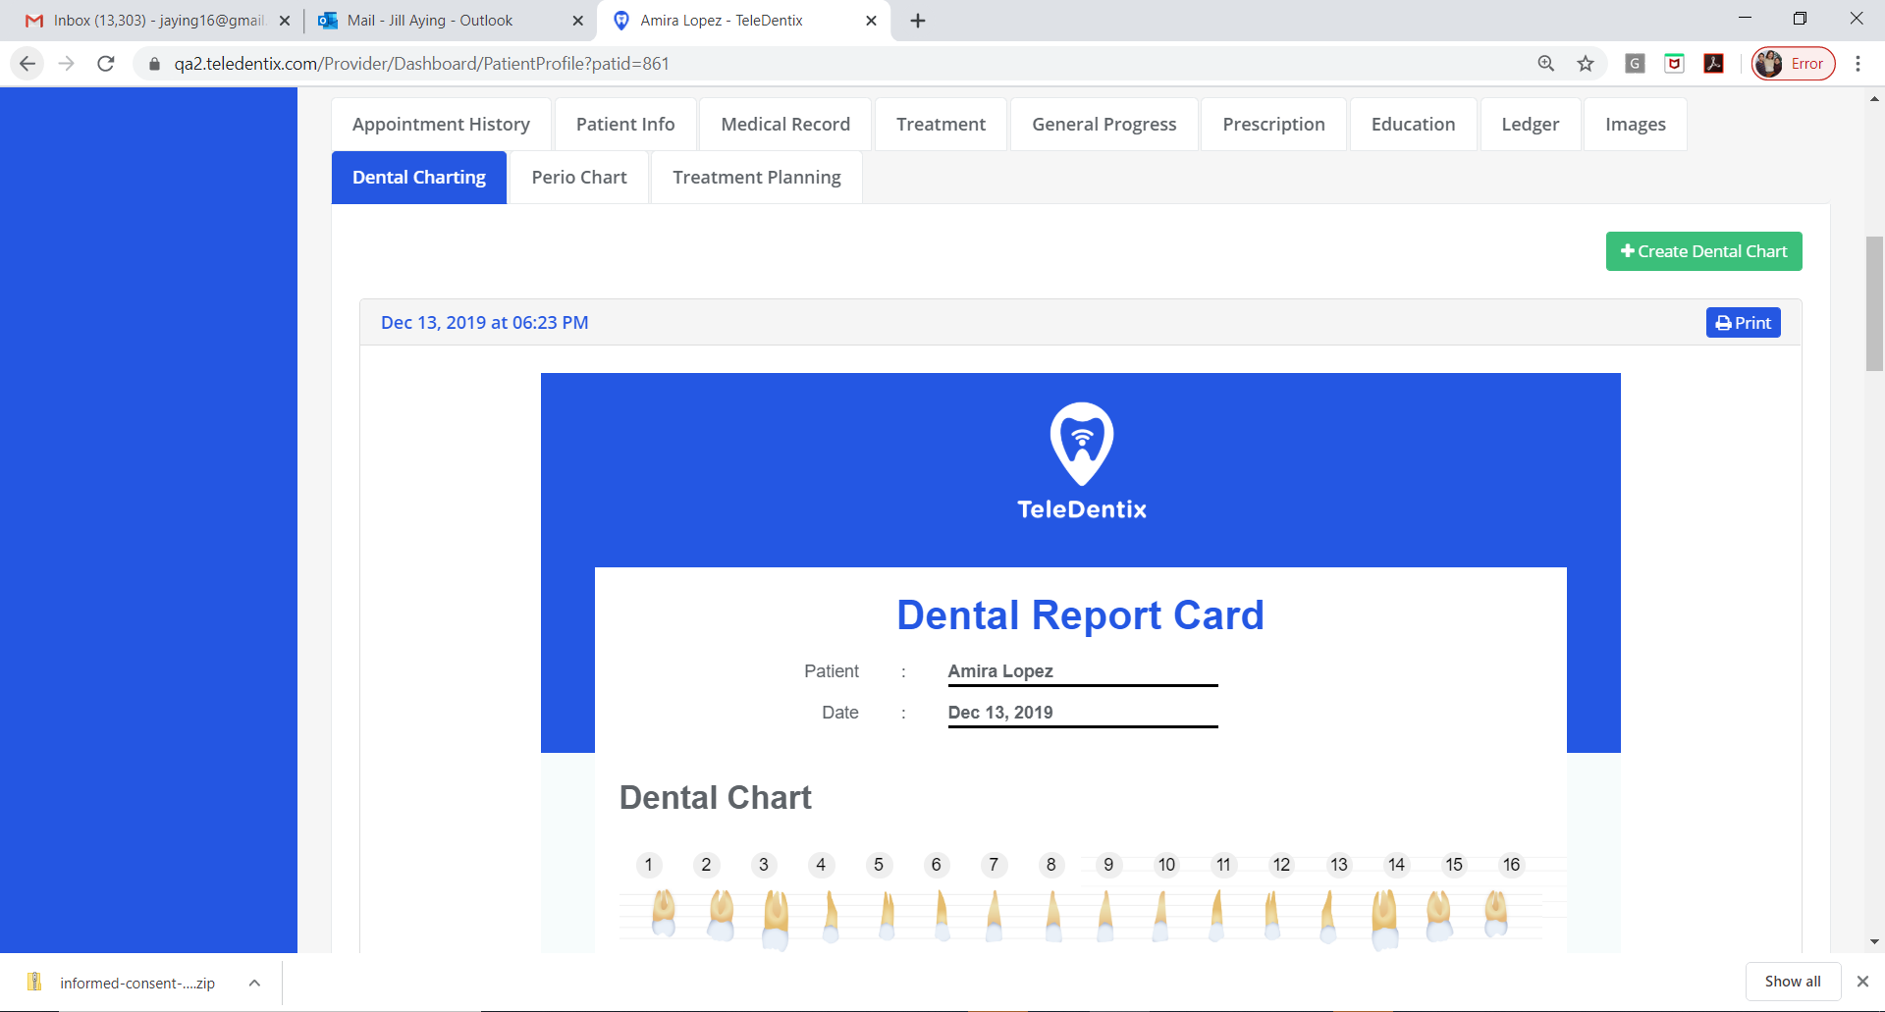

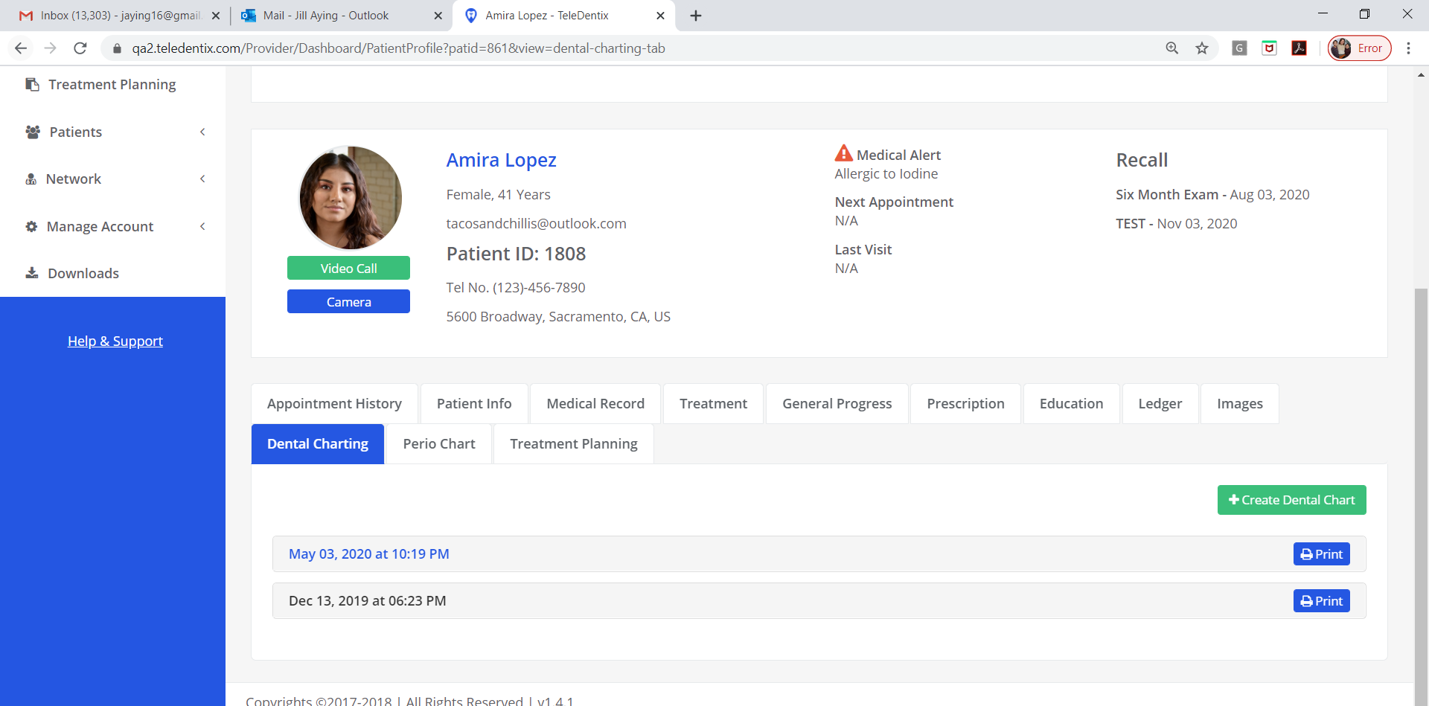

QA2 Admin – No Dental Charting found

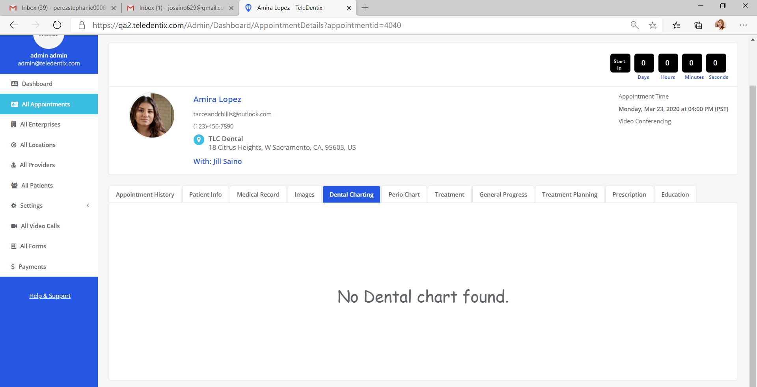

1. QA2 Provider Account – Perio Chart

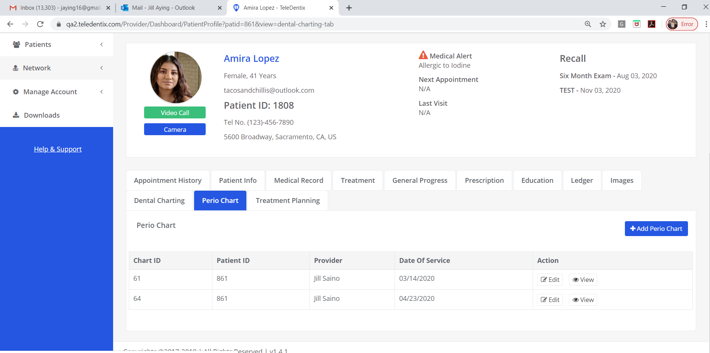

QA2 Admin Account – No Perio Chart for patient

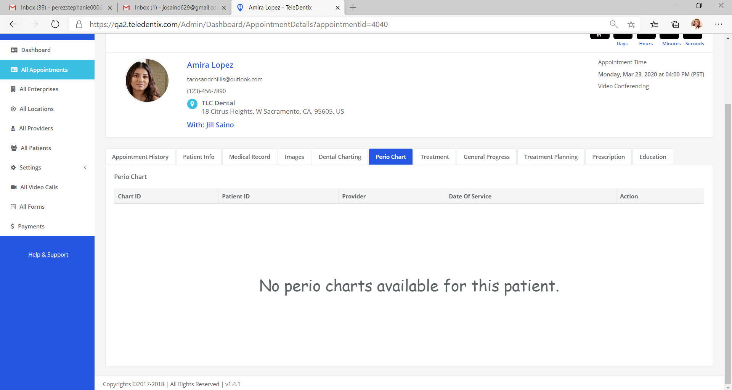

1. QA2 Provider Account – Treatment History showing only the current treatments, nothing from the past dates

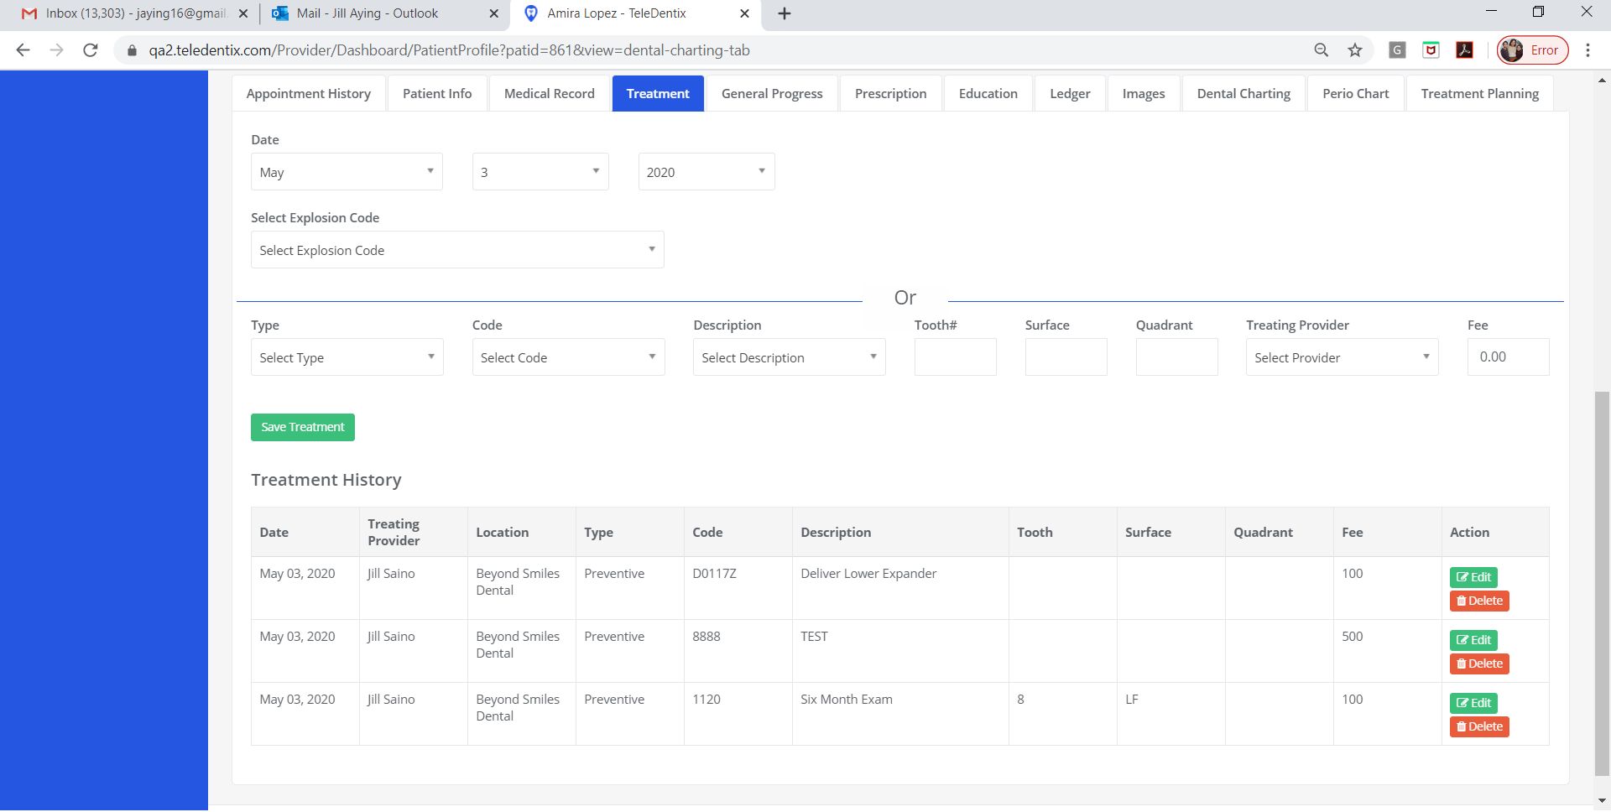

QA2 Teledentix Admin Account – Treatment history shows all records of treatment from the past:

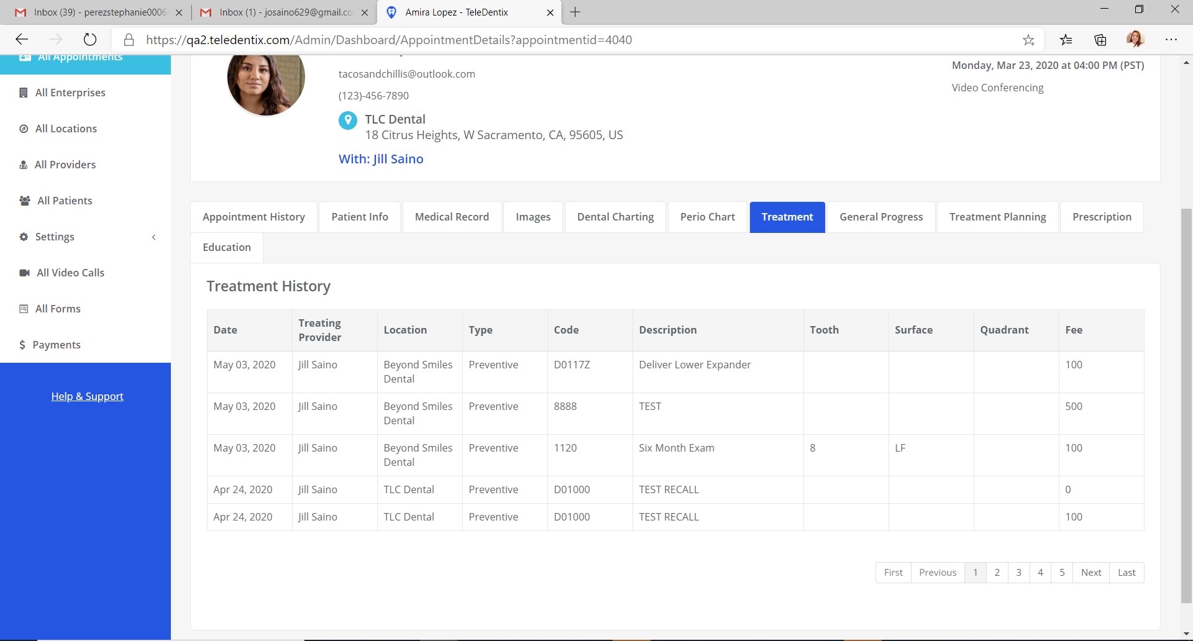

1. QA2 Provider Account - General Progress. Teardrop shows up and does not go away. Progress notes not saved. After adding progress notes a pop up message shows as: Progress notes has been saved successfully.

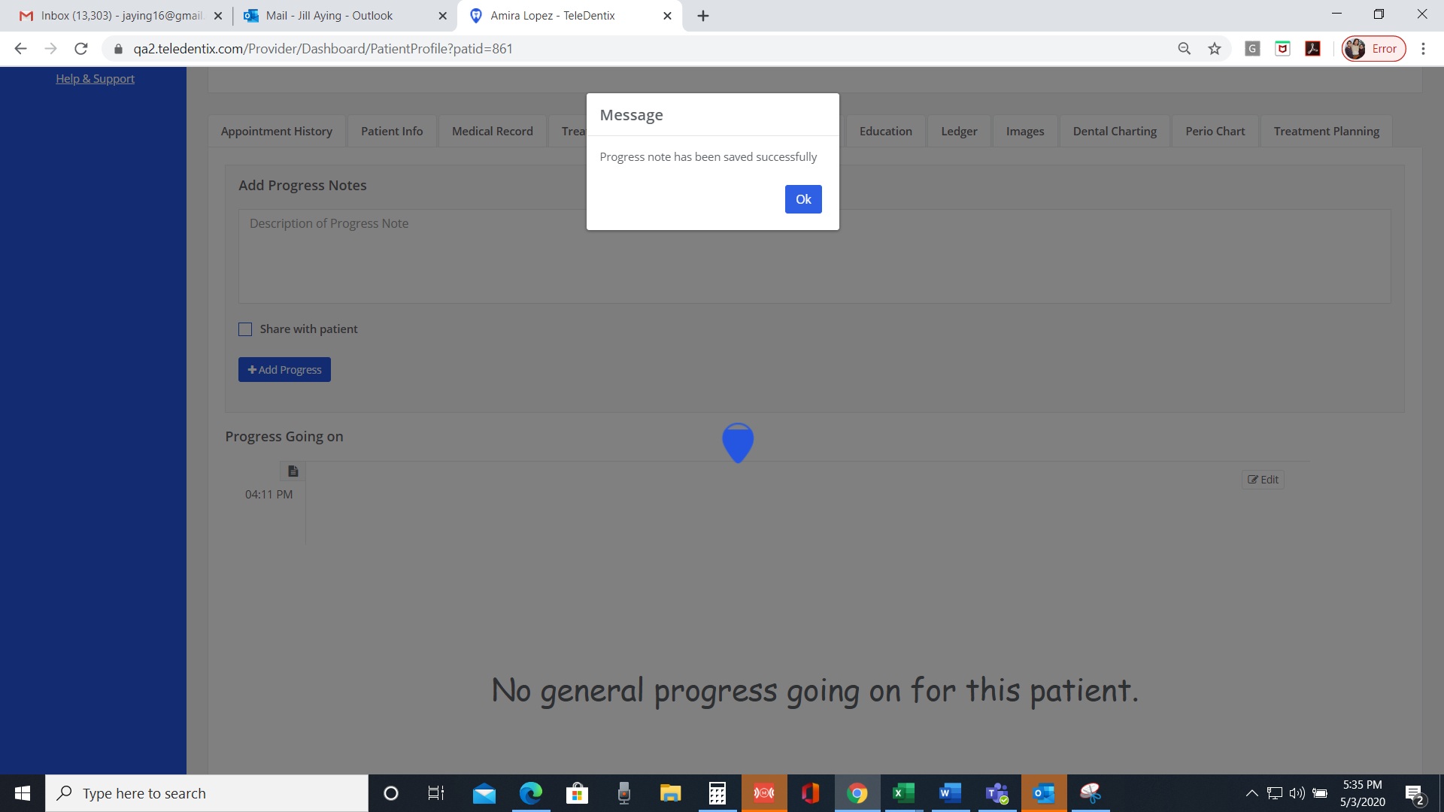

When you hit refresh, No progress notes saved:

